# General Probability Question

1) A bag contains 6 white and 4 black balls .2 balls are drawn at random. Find the probability that they are of same colour.

Answer: 7/15  
Explanation: Let S be the sample space

Then n(S) = no of ways of drawing 2 balls out of (6+4)

=10C2 10

=(10*9)/(2*1)

=45

Let E = event of getting both balls of same colour

Then,n(E) = no of ways (2 balls out of six) or (2 balls out of 4)



Therefore, P(E) = n(E)/n(S)

= 21/45

= 7/15

2) Tickets numbered 1 to 20 are mixed up and then a ticket is drawn at random. What is the probability that the ticket drawn has a number which is a multiple of 3 or 5?

Answer: C) 9/20  
  
Explanation: Here, S = {1, 2, 3, 4, ...., 19, 20}.

Let E = event of getting a multiple of 3 or 5 = {3, 6 , 9, 12, 15, 18, 5, 10, 20}.

P(E) = n(E)/n(S) = 9/20.

3) A problem is given to three students whose chances of solving it are 1/2, 1/3 and 1/4 respectively. What is the probability that the problem will be solved?

Answer:  3/4  
Explanation:

(1-1/2,1-1/3,1-1/4)

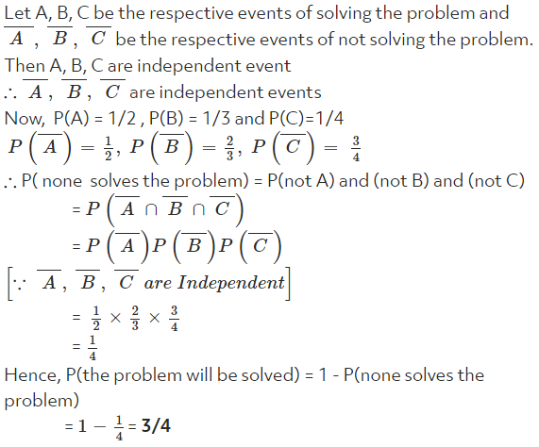

4) Two cards are drawn at random from a pack of 52 cards.what is the probability that either both are black or both are queen?

Answer: 55/221  
  
Explanation: We have n(s) =52C2 52 = 52*51/2*1= 1326.

Let A = event of getting both black cards

B = event of getting both queens

A∩B = event of getting queen of black cards

n(A) = (52*51)/(2*1) = 26C2 = 325,

n(B)=  (26*25)/(2*1)= 4*3/2*1= 6  and  n(A∩B) = 4C2 = 1

P(A) = n(A)/n(S) = 325/1326;

P(B) = n(B)/n(S) = 6/1326 and

P(A∩B) = n(A∩B)/n(S) = 1/1326

P(A∪B) = P(A) + P(B) - P(A∩B) = (325+6-1) / 1326 = 330/1326 = 55/221

5) Two dice are tossed. The probability that the total score is a prime number is:

Answer: 5/12  
  
Explanation: Clearly, n(S) = (6 x 6) = 36.

Let E = Event that the sum is a prime number.

Then E= { (1, 1), (1, 2), (1, 4), (1, 6), (2, 1), (2, 3), (2, 5), (3, 2), (3, 4), (4, 1), (4,3),(5, 2), (5, 6), (6, 1), (6, 5) }

n(E) = 15.

P(E) = n(E)/n(S) = 15/36 = 5/12.

6) A man and his wife appear in an interview for two vacancies in the same post. The probability of husband's selection is (1/7) and the probability of wife's selection is (1/5). What is the probability that only one of them is selected?

Answer:  2/7  
  
Explanation:

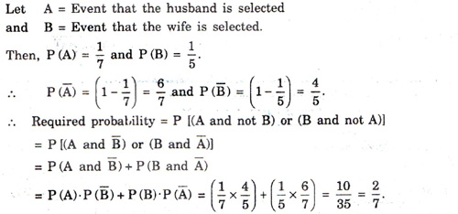

7) A bag contains 4 white, 5 red and 6 blue balls. Three balls are drawn at random from the bag. The probability that all of them are red, is:

Answer: 2/91  
  
Explanation: Let S be the sample space.

Then, n(S) = number of ways of drawing 3 balls out of 15

= 15C3  =(15*14*13)/(3*2*1)= 455.

Let E = event of getting all the 3 red balls.

n(E) = 5C3 = (5*4)/(2*1) = 10.

=> P(E) = n(E)/n(S) = 10/455 = 2/91.

8) In a lottery, there are 10 prizes and 25 blanks. A lottery is drawn at random. What is the probability of getting a prize?

Answer:  2/7  
  
Explanation: Total number of outcomes possible, n(S) = 10 + 25 = 35

Total number of prizes, n(E) = 10

P(E)=n(E)/n(S)=10/35=2/7

9) In a class, there are 15 boys and 10 girls. Three students are selected at random. The probability that 1 girl and 2 boys are selected, is:

Answer: 21/46  
Explanation: Let , S -  sample space

E - event of selecting 1 girl and 2 boys.

Then, n(S) = Number ways of selecting 3 students out of 25

= 25C3

= 2300.

n(E) = 10C1×15C2 = 1050.

https://latex.codecogs.com/gif.latex?%5Cinline%20%5Cfn_jvn%20%5Ctherefore P(E) = n(E)/n(s) = 1050/2300 = 21/46

10) A bag contains 6 black and 8 white balls. One ball is drawn at random. What is the probability that the ball drawn is white?

Answer: 4/7  
  
Explanation: Let number of balls = (6 + 8) = 14.

Number of white balls = 8.

P (drawing a white ball) = 8 /14 = 4/7.

11) Two cards are drawn together from a pack of 52 cards. The probability that one is a spade and one is a heart, is:

Answer: 13/102  
  
Explanation: Let S be the sample space.

Then, n(S) = 52C2=(52 x 51)/(2 x 1) = 1326.

Let E = event of getting 1 spade and 1 heart.

n(E)= number of ways of choosing 1 spade out of 13 and 1 heart out of 13 = (13C1)*(13C1) = 169.

P(E) = n(E)/n(S) = 169/1326 = 13/102.

12) One card is drawn at random from a pack of 52 cards. What is the probability that the card drawn is a face card (Jack, Queen and King only)?

Answer: 3/13  
  
Explanation:

Clearly, there are 52 cards, out of which there are 12 face cards.

P (getting a face card) = 12/52=3/13.

13) Three unbiased coins are tossed. What is the probability of getting at least 2 heads?

Answer: 1/2  
Explanation:  
Here S= {TTT, TTH, THT, HTT, THH, HTH, HHT, HHH}.

Let E = event of getting at least two heads = {THH, HTH, HHT, HHH}.

P(E) = n(E) / n(S)

= 4/8= 1/2

14) Two dice are thrown together .What is the probability that the sum of the number on the two faces is divided by 4 or 6.

Answer: 7/18  
  
Explanation: Clearly, n(S) = 6 x 6 = 36  
Let E be the event that the sum of the numbers on the two faces is divided by 4 or 6.  
Then,E = {(1,3),(1,5),(2,2),(2,4),(2,6),(3,1),(3,3),(3,5),(4,2),(4,4),(5,1),(5,3),(6,2),(6,6)}  
n(E) = 14.  
Hence, P(E) = n(E)/n(S) = 14/36 = 7/18

15) What is the probability of getting 53 Mondays in a leap year?

Answer: 2/7  
  
Explanation: 1 year = 365 days . A leap year has 366 days

A year has 52 weeks. Hence there will be 52 Sundays for sure.

52 weeks = 52 x 7 = 364days

366 – 364 = 2 days

In a leap year there will be 52 Sundays and 2 days will be left.

These 2 days can be:

1. Sunday, Monday

2. Monday, Tuesday

3. Tuesday, Wednesday

4. Wednesday, Thursday

5. Thursday, Friday

6. Friday, Saturday

7. Saturday, Sunday

Of these total 7 outcomes, the favourable outcomes are 2.

Hence the probability of getting 53 days = 2/7

16) A basket contains 10 apples and 20 oranges out of which 3 apples and 5 oranges are defective. If we choose two fruits at random, what is the probability that either both are oranges or both are non defective?

Answer: 316/435  
Explanation:  
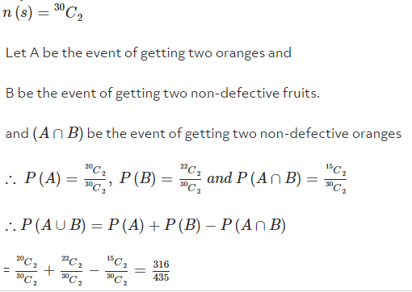

17) In a class, 30% of the students offered English, 20% offered Hindi and 10% offered both. If a student is selected at random, what is the probability that he. has offered English or Hindi ?

Answer:  2/5  
  
Explanation:

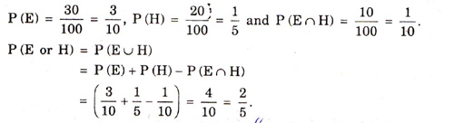

18) Four dice are thrown simultaneously. Find the probability that all of them show the same face.

Answer: A) 1/216  
  
Explanation:

The total number of elementary events associated to the random experiments of throwing four dice simultaneously is:

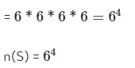

Let X be the event that all dice show the same face.

X = { (1,1,1,1,), (2,2,2,2), (3,3,3,3), (4,4,4,4), (5,5,5,5), (6,6,6,6)}

n(X) = 6



19) Three unbiased coins are tossed. What is the probability of getting at most two heads?

Answer: 7/8  
  
Explanation:

Here S = {TTT, TTH, THT, HTT, THH, HTH, HHT, HHH}

Let E = event of getting at most two heads.

Then E = {TTT, TTH, THT, HTT, THH, HTH, HHT}.

P(E) =n(E)/n(S)=7/8.

20) A speaks truth in 75% of cases and B in 80% of cases. In what percentage of cases are they likely to contradict each other, narrating the same incident

Answer: 35/100

Explanation: Let   A = Event that A speaks the truth

B = Event that B speaks the truth

Then P(A) = 75/100 = 3/4

P(B) = 80/100 = 4/5

Now, A and B contradict each other = [A lies and B true] or [B true and B lies]



= P(A).P(B-lie) + P(A-lie).P(B)

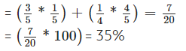

21) What is the probability of getting a sum 9 from two throws of a dice?

Answer: 1/9  
Explanation: In two throws of a die, n(S) = (6 x 6) = 36.

Let E = event of getting a sum ={(3, 6), (4, 5), (5, 4), (6, 3)}.

P(E) =n(E)/n(S)=4/36=1/9.

22) If two letters are taken at random from the word HOME, what is the probability that none of the letters would be vowels?

Answer: 1/6  
Explanation: P(first letter is not vowel) = 2/4

P(second letter is not vowel) = 1/3

So, probability that none of letters would be vowels is = (2/4)×(1/3)=1/6

23) A bag contains 50 tickets numbered 1,2,3,4......50 of which five are drawn at random and arranged in ascending order of magnitude.Find the probability that third drawn ticket is equal to 30.

Answer: 551/15134  
  
Explanation: Total number of elementary events = 50C5  
Given,third ticket =30

=> first and second should come from tickets numbered 1 to 29 = 29C2 ways and remaining two in 20C2 ways.

Therfore,favourable number of events = (29C2)*(20C2)

Hence,required probability = (29C2)*(20C2)/(50C5) =551 / 15134

24) A bag contains 4 red and 3 black balls. A second bag contains 2 red and 4 black balls. One bag is selected at random. From the selected bag, one ball is drawn. Find the probability that the ball drawn is red.

Answer: 19/42  
  
Explanation: A red ball can be drawn in two mutually exclusive ways

(i) Selecting bag I and then drawing a red ball from it.

(ii) Selecting bag II and then drawing a red ball from it.

Let E1, E2 and A denote the events defined as follows:

E1 = selecting bag I,

E2 = selecting bag II

A = drawing a red ball

Since one of the two bags is selected randomly, therefore

P(E1) = 1/2 and P(E2) = 1/2

Now, P(A/E1) = Probability of drawing a red ball when the first bag has been selected = 4/7

P(A/E2) = Probability of drawing a red ball when the second bag has been selected

= 2/6

Using the law of total probability, we have

P(red ball) = P(A) = P(E1)×P(A/E1)+P(E2)×P(A/E2)

= ½ × 4/7 + ½ × 2/6 =19/42

25) In a box, there are 8 red, 7 blue and 6 green balls. One ball is picked up randomly. What is the probability that it is neither red nor green?

Answer: 1/3  
Explanation: Total number of balls = (8 + 7 + 6) = 21.

Let E = event that the ball drawn is neither red nor green

S = event that the ball drawn is blue.

n(E) = 7.

P(E) = n(E)/n(S) = 7/21 = 1/3.

26) A word consists of 9 letters; 5 consonants and 4 vowels. Three letters are choosen at random. What is the probability that more than one vowel will be selected ?

Answer: 17/42  
Explanation: 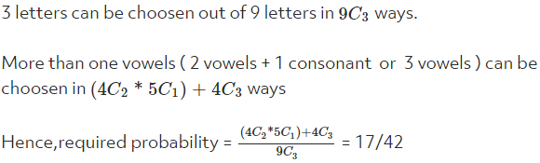

27) A bag contains 2 red, 3 green and 2 blue balls. Two balls are drawn at random. What is the probability that none of the balls drawn is blue?

Answer: 10/21  
Explanation: Total number of balls = (2 + 3 + 2) = 7.

Let S be the sample space.

Then, n(S) = Number of ways of drawing 2 balls out of 7 =7C2 = 21

Let E = Event of drawing 2 balls, none of which is blue.

n(E) = Number of ways of drawing 2 balls out of (2 + 3) balls =5C2 = 10

Therefore, P(E) = n(E)/n(S) = 10/ 21.

28) In a simultaneous throw of pair of dice. Find the probability of getting the total more than 7.

Answer:  5/12  
Explanation: Here n(S) = (6 x 6) = 36

Let E = event of getting a total more than 7  
        = {(2,6),(3,5),(3,6),(4,4),(4,5),(4,6),(5,3),(5,4),(5,5),(5,6),(6,2),(6,3),(6,4),(6,5),(6,6)}

Therefore, P(E) = n(E)/n(S) = 15/36 = 5/12.

29) A box contains 10 bulbs,of which just three are defective. If a random sample of five bulbs is drawn, find the probability that the sample contains exactly one defective bulb.

Answer: 5/12  
Explanation: Total number of elementary events = 10C5

Number of ways of selecting exactly one defective bulb out of 3 and 4 non-defective out of 7 is 3C1*7C4

So, required probability =3C1*7C4/10C5 = 5/12.

30) Two dice are thrown simultaneously. What is the probability of getting two numbers whose product is even?

Answer: 3/4  
Explanation: In a simultaneous throw of two dice, we have n(S) = (6 x 6) = 36.

Then, E= {(1, 2), (1, 4), (1, 6), (2, 1), (2, 2), (2, 3), (2, 4), (2, 5), (2, 6), (3, 2), (3,4),(3, 6), (4, 1), (4, 2), (4, 3), (4, 4), (4, 5), (4, 6), (5, 2), (5, 4), (5, 6), (6, 1),6, 2), (6, 3), (6, 4), (6, 5), (6, 6)}

n(E) = 27.

P(E) = n(E)/n(S) = 27/36 = 3/4.

31) A letter is taken out at random from 'ASSISTANT'  and another is taken out from 'STATISTICS'. The probability that they are the same letter is :

Answer: 19/90  
  
Explanation: ASSISTANT→AAINSSSTT

STATISTICS→ACIISSSTTT

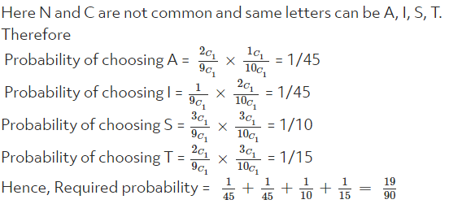

32) Two brother X and Y appeared for an exam. The probability of selection of X is 1/7 and that of B is 2/9. Find the probability that both of them are selected.

Answer: 2/63  
Explanation: Let A be the event that X is selected and B is the event that Y is selected.

P(A) = 1/7,  P(B) = 2/9.

Let C be the event that both are selected.

P(C) = P(A) × P(B) as A and B are independent events:

= (1/7) × (2/9)  = 2/63

33) In a single throw of two dice , find the probability that neither a doublet nor a total of 8 will appear.

Answer:  5/18  
Explanation: n(S) = 36

A = {(1, 1), (2, 2), (3, 3), (4, 4), (5, 5), (6, 6)}

B = { (2, 6), (3, 5), (4, 4), (5, 3), (6, 2) }

n(A)=6, n(B)=5, n(A∩B)=1

∴ Required probability = P(A∪B)

= P(A)+P(B)−P(A∩B)

=  6/36+5/36-1/36 = 5/18

34) Three houses are available in a locality. Three persons apply for the houses. Each applies for one house without consulting others. The probability that all the three apply for the same house is :

Answer:  1/9  
Explanation: One person can select one house out of 3= 3C1 ways =3.

Hence, three persons can select one house out of 3 in 3 x 3 x 3 =9.

Therefore, probability that all thre apply for the same house is 1/9

35) In a race, the odd favour of cars P,Q,R,S are 1:3, 1:4, 1:5 and 1:6 respectively. Find the probability that one of them wins the race.

Answer: 319/420  
Explanation: P(P)=1/4,P(Q)=1/5,P(R)=1/6,P(S)=1/7  
All the events are mutually exclusive hence,

Required probability = P(P)+P(Q)+P(R)+P(S)

1/4+1/5+1/6+1/7

=319/420

36) From a pack of 52 cards, 3 cards are drawn. What is the probability that one is ace, one is queen and one is jack?

Answer: 16/5525

Explanation: Required probability:

(4C1*4C1*4C1)/52C3

=4*4*4/22100

=16/5525

37) An unbiased die is tossed.Find the probability of getting a multiple of 3

Answer: 1/3  
Explanation: Here S = {1,2,3,4,5,6}

Let E be the event of getting the multiple of 3

Then, E = {3,6}

P(E) = n(E)/n(S) = 2/6 = 1/3

38) What is the probability of getting at least one six in a single throw of three unbiased dice?

Answer: 91/256  
Explanation: Find the number of cases in which none of the digits show a '6'.  
  
i.e. all three dice show a number other than '6', 5×5×5=125 cases.  
  
Total possible outcomes when three dice are thrown = 216.  
  
The number of outcomes in which at least one die shows a '6' = Total possible outcomes when three dice are thrown - Number of outcomes in which none of them show '6'.  
  
=216−125=91  
  
The required probability = 91/256

39) There are four hotels in a town. If 3 men check into the hotels in a day then what is the probability that each checks into a different hotel?

Answer: 3/8  
Explanation: Total cases of checking in the hotels = 4 x 4 x 4 = 64 ways.

Cases when 3 men are checking in different hotels = 4×3×2 = 24 ways.

Required probability =24/64

= 3/8

40) An urn contains 4 white 6 black and 8 red balls . If 3 balls are drawn one by one without replacement, find the probability of getting all white balls.

Answer: 1/204  
  
Explanation: 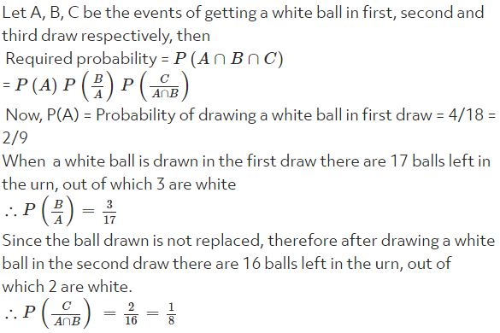

41) Two cards are drawn from a pack of well shuffled cards. Find the probability that one is a club and other in King

Answer: 1/26  
Explanation: Let X be the event that cards are in a club which is not king and other is the king of club.  
Let Y be the event that one is any club card and other is a non-club king.  
Hence, required probability:  
=P(A)+P(B)

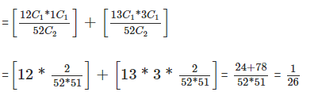

42) I forgot the last digit of a 7-digit telephone number. If 1 randomly dial the final 3 digits after correctly dialing the first four, then what is the chance of dialing the correct number?

Answer: 1/1000  
Explanation: It is given that last three digits are randomly dialled. then each of the digit can be selected out of 10 digits in 10 ways.  
Hence required probability == 1/1000

43) A box contains 100 balls, numbered from 1 to 100. If three balls are selected at random and with replacement from the box, what is the probability that the sum of the three numbers on the balls selected from the box will be odd?

Answer: 1/2  
Explanation: P(odd) = P (even) =(1/2) 1(because there are 50 odd and 50 even numbers)

Sum or the three numbers can be odd only under the following 4 scenarios:

Odd + Odd + Odd = 1/2*1/2*1/2= 1/8

Odd + Even + Even = 1/2*1/2*1/2=1/8

Even + Odd + Even = 1/2*1/2*1/2=1/8

Even + Even + Odd = 1/2*1/2*1/2 = 1/8

Other combinations of odd and even will give even numbers.

Adding up the 4 scenarios above:

= 1/8+ 1/8+1/8+ 1/8

= 4/8

= 1/2

44) A number X is chosen at random from the numbers -3, -2, -1, 0, 1, 2, 3. What is the probability that |X|<2

Answer: 3/7  
Explanation: X can take 7 values.  
To get |X|+2) take X={−1,0,1}

=> P(|X|<2) = Favourable Cases

Total Cases = 3/7

45) A coin is tossed 5 times. What is the probability that head appears an odd number of times?

Answer: 1/2  
Explanation: The possible outcomes are as follows :

5H, 5T, (H, 4T), (T, 4H), (2H, 3T) (3H, 2T), i.e. 6 outcomes in all.

Therefore the probability that head appears an odd number of times = 3/6 =1/2

(In only three outcomes out of the six outcomes, head appears an odd number of times).

46) In a simultaneous throw of two dice, what is the probability of getting a doublet ?

Answer: 1/6  
Explanation: In a simultaneous throw of two dice, n(S) = 6 x 6 = 36

Let E = event of getting a doublet = { (1,1), (2,2), (3,3), (4,4), (5,5), (6,6)}

P(E)=n(E)/n(S)

=6/36

=1/6

47) If a box contains 10 bulbs,of which just three are defective. If a random sample of five bulbs is drawn, find the probability that the sample contains no defective bulbs.

Answer: 1/12  
Explanation: Total number of elementary events = 10C5

Number of ways of selecting no defective bulbs i.e., 5 non-defective bulbs out of 7 is 7C5.

So,required probability =7C5/ 10C5 = 1/12.

48) 8 couples (husband and wife) attend a dance show "Nach Baliye' in a popular TV channel ; A lucky draw in which 4 persons picked up for a prize is held, then the probability that there is atleast one couple will be selected is :

Answer: 15/39  
Explanation: P( selecting atleast one couple) = 1 - P(selecting none of the couples for the prize)



49) What is the probability that a leap year has 53 Saturdays and 52 Sundays ?

Answer: 1/7  
Explanation: A leap year has 52 weeks and two days  
Total number of cases = 7  
Number of favourable cases = 1  
i.e., {Friday, Saturday}

Required Probability = 1/7

50) If an unbiased dice is rolled once, the odds in favour of getting a point which is multiple of 3 is:

Answer: 1/3  
Explanation: Total number =6

Getting a 'multiple of 3' = 2

So, probability = 2/6 =1/3